1. Forecast monitoring app
Dataset
Actual generation
Forecasted generation
Application
2. Analysis
3. Submission

The challenge involves two parts: (i) building a forecast monitoring app and (ii) doing analysis of the forecasts.

Forecast monitoring app
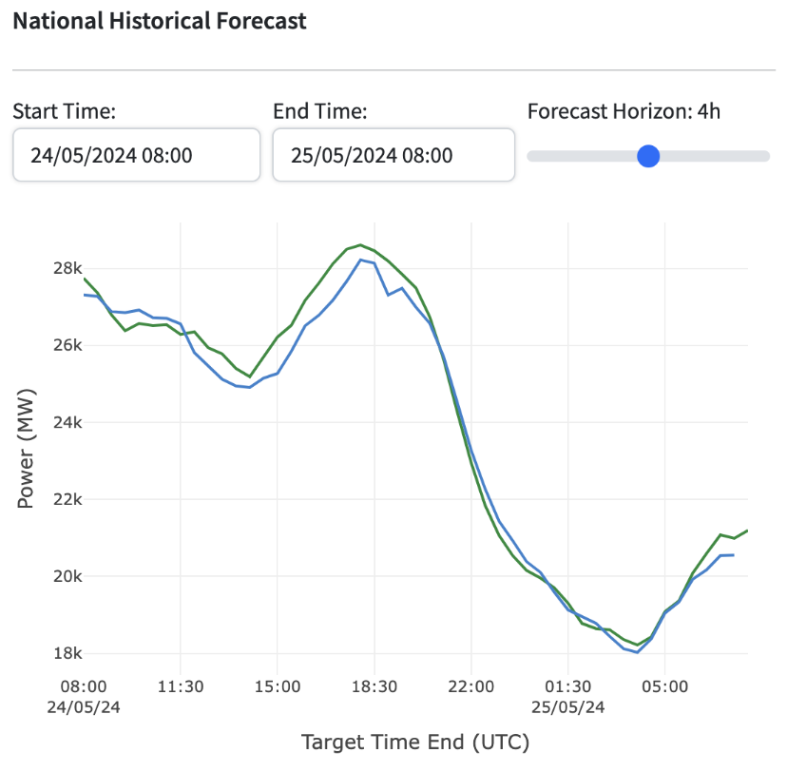
Figure 1: Sample UI

The goal of this app is to help the end user intuitively understand the accuracy of the forecasts. The quantity being forecasted is the national-level wind power generation in the United Kingdom.

An example design is provided in Figure 1. For a time range between “start time” and “end time” (selected via calendar widgets), the app displays the actual generation values (blue line) and the forecasted generation values (green line). The latest forecasts that were created at least 4 hours (Forecast horizon - configurable using slider) before each target time are shown. For example, for a target time of 24/05/24 18:00, it shows the value of the latest forecast which was created before 24/05/24 14:00 (i.e., 18 - 4). Here, target time corresponds to the time at which wind power was generated and measured.

Dataset

Actual generation
The actual generation data for this is available at https://bmrs.elexon.co.uk/api-documentation/endpoint/datasets/FUELHH/stream. Please consider values corresponding to “fuelType” “WIND”. The relevant fields are:

- "startTime": the target time (resolution of 30 minutes)
- “generation”: generated wind power

Forecasted generation
The forecasts are available at https://bmrs.elexon.co.uk/api-documentation/endpoint/datasets/WINDFOR/stream. Relevant fields:
- “startTime”: similar to the "startTime" field in the actuals dataset
- "publishTime": the time at which the forecast was created
- “generation": similar to the "generation" field in the actuals dataset

Please consider data only for January 2024. Please consider the values where the forecast horizon is between 0-48 hrs.

For any missing forecast data, ignore them and don’t plot any values.

Please note that the numbers shown in Figure 1 are for illustrative purposes only and may not match with the data available in the API.

Application

Please build the application using any tech stack you’re strong at. You are free to use AI tools to assist with building this application (please mention it explicitly in the README if you’ve used AI tools). Please deploy the sample application in vercel/heroku or similar platforms.

Please ensure that both the web and mobile views work well. If you feel that the app can be improved beyond the design provided in Figure 1, please feel free to do so.

Analysis

For this analysis, you can use AI tools for low-level help (e.g., fixing bugs, calling a library function). Please do not use AI tools to do this end-to-end. The goal is to see your own analytical thinking derived from first principles. We want to understand your reasoning process, so please document every step clearly, explain your assumptions, trade-offs, and conclusions in detail, and show the logical path you followed.

- Please create a Jupyter notebook that analyzes the forecast dataset. The goal of the analysis is to understand the error characteristics of the model. The analysis is open-ended. Some ideas: mean, median and p99 error; variation in error as forecast horizon changes, error at different times of the day.
- Wind power generation is heavily dependent on weather. Based on the past wind generation data, we need to understand how reliably wind power can meet our electricity demand. Please analyze historical actual generation of wind. Based on the analysis, please recommend how many MW of wind power can we reliably expect to be available to meet the electricity demand. The answer is subjective. Hence, support your recommendation with relevant reasoning and evidence. Please share a Jupyter notebook with this analysis and recommendation.

Submission
Please create a git repo to submit your code and notebooks. Please include a README containing:
- Details of the files and directories present
- How to start the application
- Link to the vercel/heroku app

Please create a zip archive of the git repo, upload it to your google drive and share the link (accessible to all). Please make sure to include the .git directory in the repo, so that we’ll be able to review the commit history too.

Please create an unlisted youtube video to show the demo of your application and to summarize the analysis you’ve done. Please limit it to a maximum of 5 minutes. A screen recording with your narration would do. Please make sure to cover the work you did on front-end, back-end and analysis.

Please send an email to hiring@reint.ai with following details:

Subject: Full Stack SWE challenge submission

Content:

Demo video link: <link to unlisted youtube video>
App demo link: <Link to the app (e.g., vercel/heroku)>
Repo link: <google drive link>

Name: <>
Wellfound URL: <>
Linkedin URL: <>
Resume: <google drive link>
Phone no.: <>

—---

Sending the above email would be sufficient. We’ll be reviewing all emails. No need to send a separate message via wellfound with your submission.

There’s no deadline for submission. Earlier the better, as the hiring process is ongoing.

We strongly recommend that you treat your submission with the highest level of rigor and attention to detail. Everything you submit must be of the utmost quality, this assignment is specifically designed to reflect the standard of work we expect from a Software Engineer on our team.

Best wishes!

